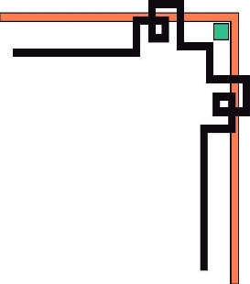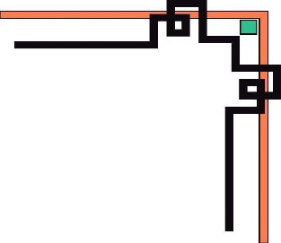

**DANANG SOFTWARE CORPORATION**

**SOFTECH-APTECH**



EProject Semester 2:

**CAFE VINE**

Guiding faculty: Mr. Nguyen Duc Thao

Members:

* Nguyen Viet Huynh
* Nguyen Anh Tan
* Nguyen Van Trong

Group: Vine

Batch: 130

**Da nang, 19th September 2017**

Content

1. ACKNOWLEDGEMENT 3

2. INTRODUCTION: 3

3. PROBLEM DEFINITION 4

3.1 Login, Log off 4

3.2. A User Management 4

3.3 Administrator interface and User interface 4

3.4 Product Functions 4

3.5 Order Functions 4

4. REQUIREMENT ATTRIBUTES. 5

4.1. Main Requirements. 5

4.2. Use case Diagram 5

4.2. Database Diagram 6

5. PROJECT PLANNING 7

6. TECHNICAL. 7

7. GUI OF CAFE VINE. 8

# ACKNOWLEDGEMENT

We are very grateful to Thao Nguyen Duc who has many years of experience helping us to research, analyze and advise us to complete this project and other teachers who helped us. Support us during the project implementation.

All my classmates had the pleasure of working with all of you in the class. We have discussed many things about the project and helped each other on many issues. Thanks everyone.

We are very grateful to all staff and Softech Aptech Da Nang for organizing and caring for their courses.

Finally, we would like to thank all of our classmates for their valuable suggestions.

We sincerely thank you!

# 2. INTRODUCTION:

Today, workloads are getting bigger with the change and development of technology and the economy is booming. Cafe Vine wanted us to build software to manage Cafe Vine. So our team has built such management software to meet the management needs of the goods, which is the main idea of this project.

# 3. PROBLEM DEFINITION

## 3.1 Login, Log off

This section allows registered users to log in to the system through their account names, passwords and access rights, and also allows users to register for new accounts to use this software.

## 3.2. A User Management

User management will allow management of logon, logout, user login management, add, edit, delete, update drink information, tables and any user in the system.

## 3.3 Administrator interface and User interface

It contains functions like login, logout, new account registration, statistics view, invoice management, desk management and store information.

## 3.4 Product Functions

The administrator add and edit employee information, coffee table, drinks, viewing statistics.

The staff selects the drink and sends it to the administrator to manage the table and drink.

## 3.5 Order Functions

This functional group allows employees to view a list of orders, allowing employees to edit and delete existing ordering information.

# 4. REQUIREMENT ATTRIBUTES.

## 4.1. Main Requirements.

The Main Requirements include Javafx technology and SQL Server 2014 Technology.

## 4.2. Use case Diagram

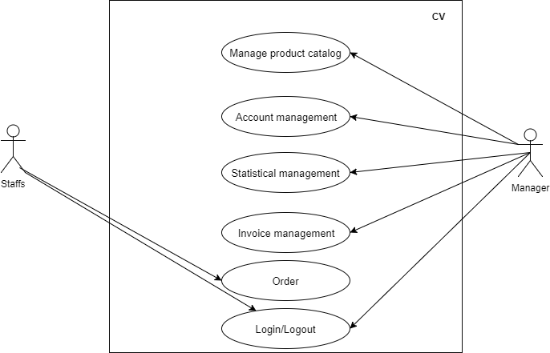

## 4.2. Database Diagram

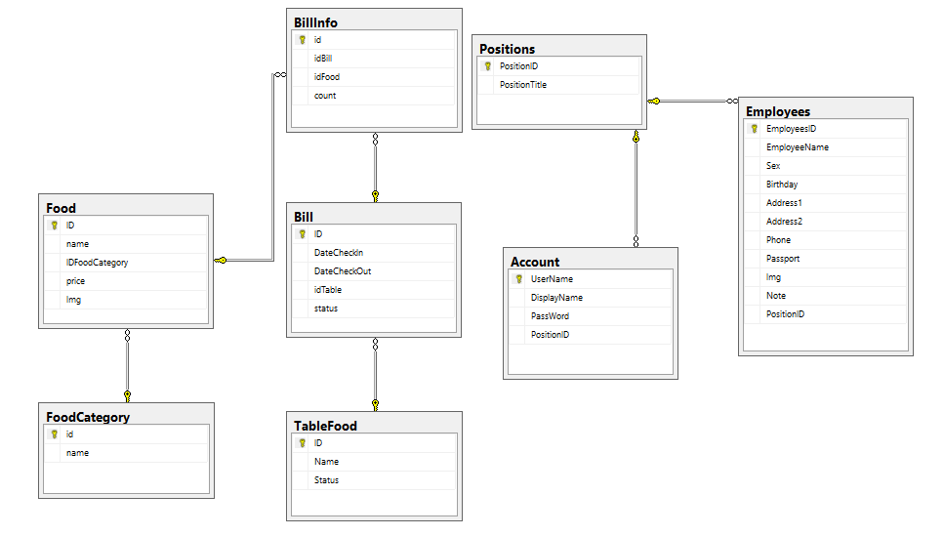

# 5. PROJECT PLANNING

|  |  |  |  |  |  |  |
| --- | --- | --- | --- | --- | --- | --- |
| **No.** | **Tasks** | **Days** | **Start date** | **End date** | **Members** | **Status** |
| 1 | Gathering requirements | 6 | 12/7 | 17/7 | All | Complete |
| 2 | Find references | 5 | 18/7 | 22/7 | All | Complete |
| 3 | Analyze Project | 7 | 23/7 | 29/7 | All | Complete |
| 4 | Analyze and Design Database | 3 | 30/7 | 1/8 | Huynh | Complete |
| 5 | Analyze Main Interface | 3 | 2/8 | 4/8 | All | Complete |
| 6 | Design Main Interface | 4 | 5/8 | 8/8 | Tan | Complete |
| 7 | Code | 23 | 9/8 | 31/8 | All | Complete |
| 8 | Testing | 3 | 1/9 | 3/9 | Tan, Trong | Complete |
| 9 | Deploying, Fix Bugs | 6 | 4/9 | 9/9 | All | Complete |
| 10 | Write Document | 3 | 10/9 | 12/9 | Huynh | Complete |
| 11 | Report prepared by slide (power point) | 3 | 13/9 | 15/9 | Trong | Complete |

# 6. TECHNICAL.

The technique used to build the Program:

* Javafx Technology.
* Microsoft SQL Server and database

# 7. GUI OF CAFE VINE.

* SERVER

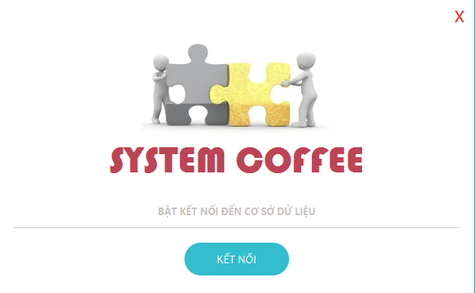

* LOGIN AND ERROR

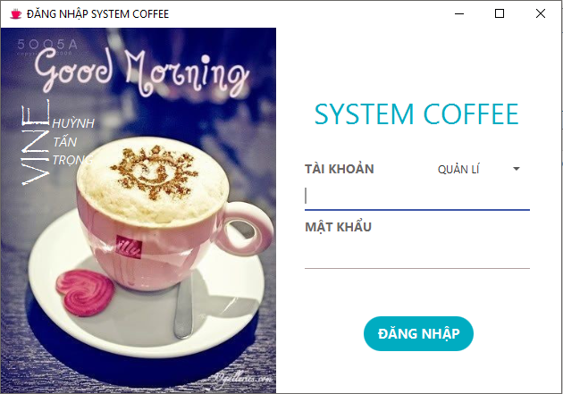

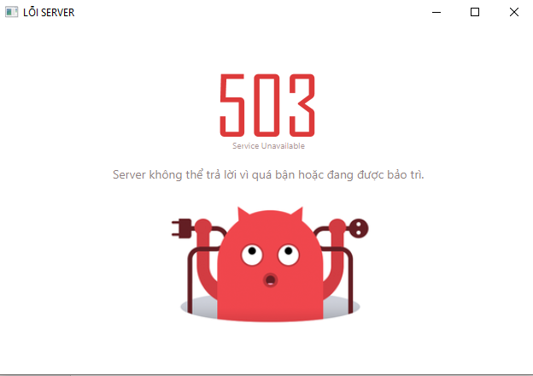

* ADMIN

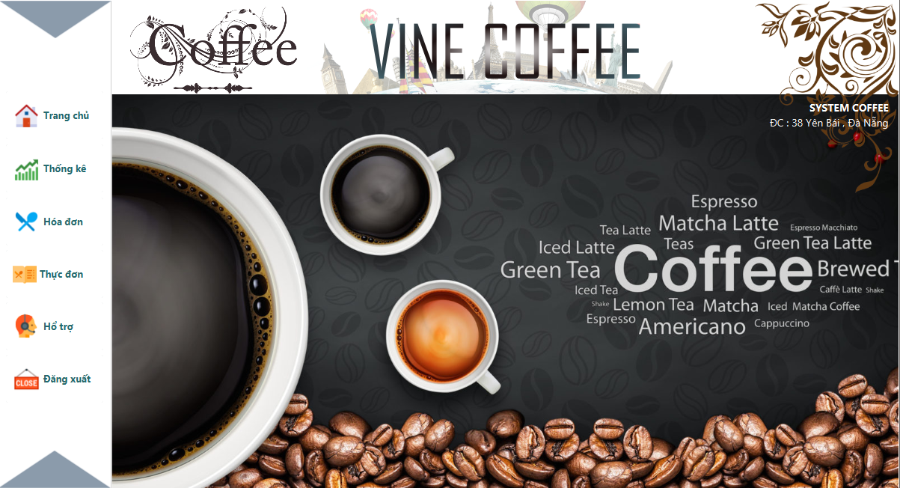

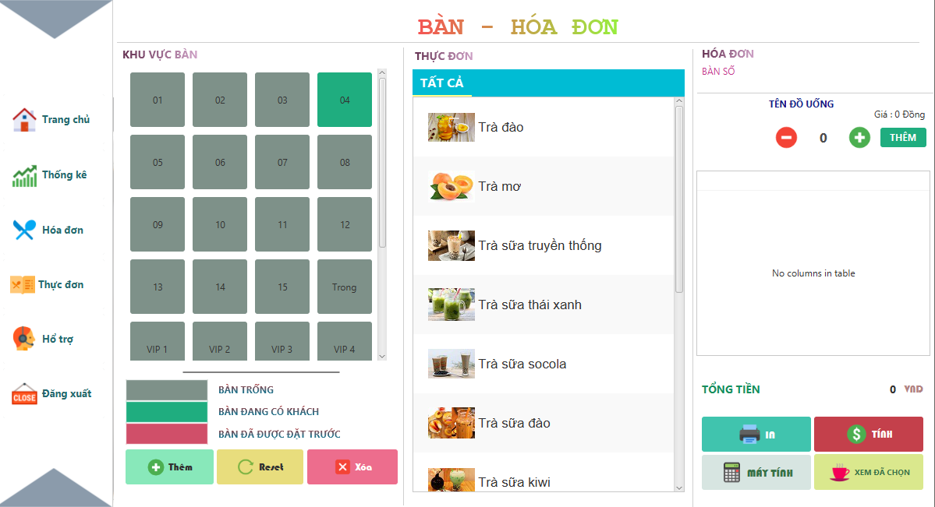

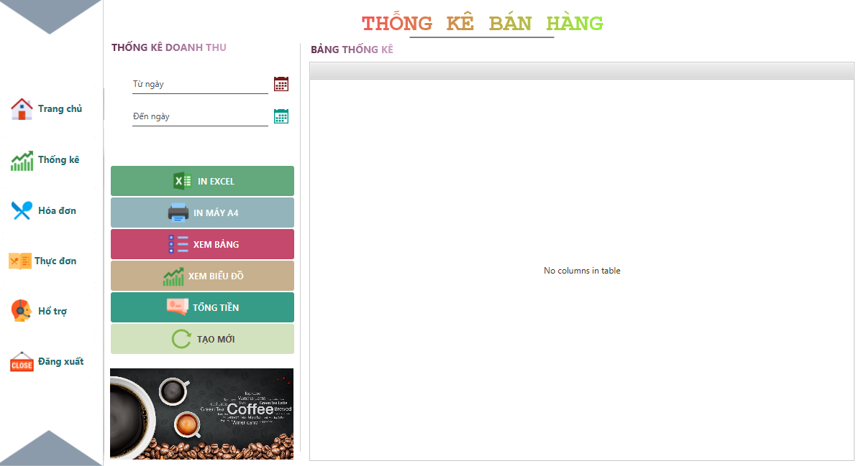

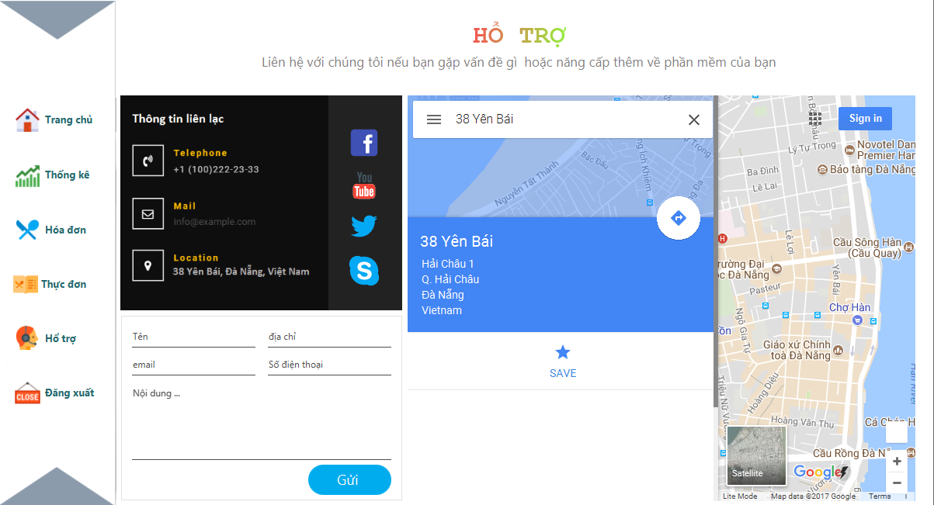

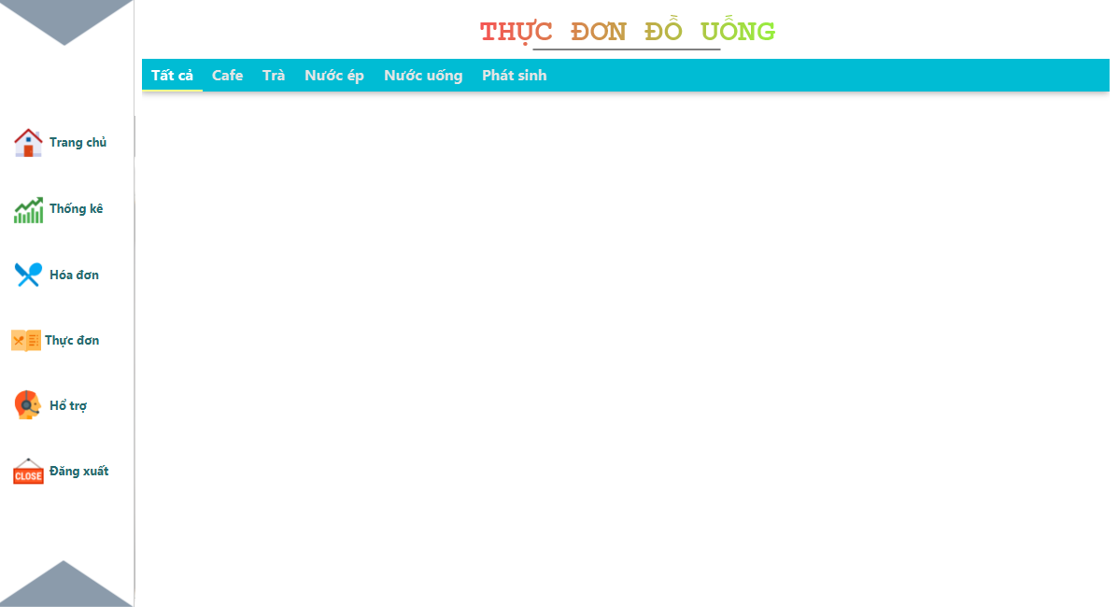

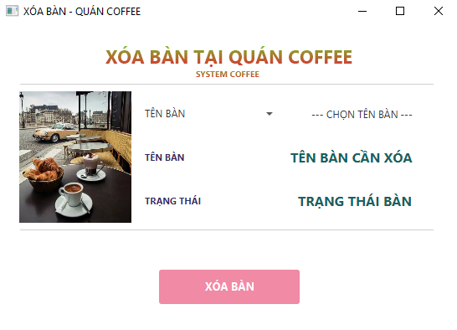

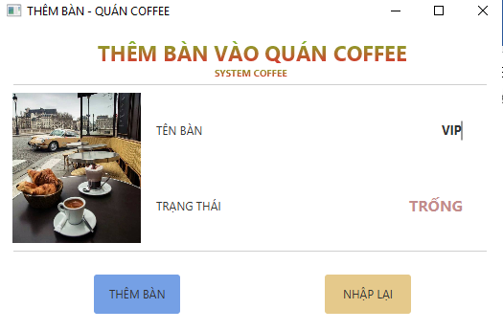

* EMPLOYEE

